**PIZZA SALES SQL QUERIES**

A. KPI’s (Key Performance Indicator)

1. Total Revenue:

SELECT SUM (total_Price) AS total_Revenue FROM pizza_sales ;

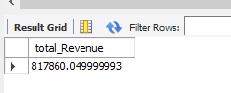

2. Average Order Value

SELECT SUM (total_Price) / COUNT (DISTINCT order_id) AS average_Revenue_Per_Order FROM pizza_sales;

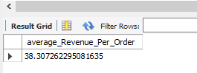

3. Total Pizzas Sold

SELECT SUM(quantity) AS total_pizza_sold FROM pizza_sales ;

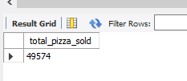

4. Total Orders

SELECT COUNT(DISTINCT order_id) AS total_orders FROM pizza_sales;

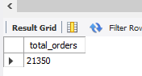

5. Average Pizzas Per Order

SELECT CAST (CAST (SUM (quantity) AS DECIMAL (10,2)) /

CAST (COUNT (DISTINCT order_id)

AS DECIMAL (10,2))

AS DECIMAL (10,2)) AS Avg_Pizzas_per_order

FROM pizza_sales ;

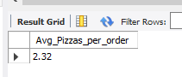

B. Daily Trends for Total Orders

SELECT DAYNAME (order_date) AS order_day, COUNT (DISTINCT order_id) AS total_orders

FROM pizza_sales

GROUP BY DAYNAME (order_date)

ORDER BY FIELD (DAYNAME (order_date), 'Monday', 'Tuesday', 'Wednesday', 'Thursday', 'Friday', 'Saturday', 'Sunday');

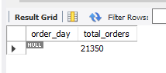

C. Monthly Trend for Orders

SELECT MONTHNAME (order_date) AS Month_Name, COUNT (DISTINCT order_id) AS Total_Orders

FROM pizza_sales

GROUP BY MONTHNAME (order_date)

ORDER BY STR_TO_DATE (MONTHNAME (order_date), '%M');

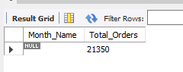

D. % of Sales by Pizza Category

SELECT pizza_category, CAST(SUM (total_price) AS DECIMAL(10,2)) as

total_revenue,CAST(SUM(total_price) * 100 / (SELECT SUM(total_price) from pizza_sales)

AS DECIMAL(10,2)) AS PCT

FROM pizza_sales

GROUP BY pizza_category;

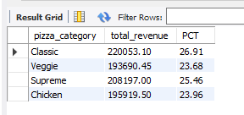

E. % of Sales by Pizza Size

SELECT pizza_size, CAST(SUM(total_price) AS DECIMAL(10,2)) as total_revenue,

CAST(SUM(total_price) * 100 / (SELECT SUM(total_price) from pizza_sales)

AS DECIMAL(10,2)) AS PCT

FROM pizza_sales

GROUP BY pizza_size

ORDER BY pizza_size;

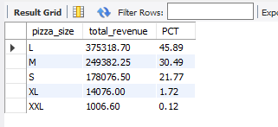

F. Total Pizzas Sold by Pizza Category

SELECT pizza_category, SUM(quantity) AS Total_Quantity_Sold

FROM pizza_sales

WHERE MONTH(order_date) = 2

GROUP BY pizza_category

ORDER BY Total_Quantity_Sold DESC;

G. Top 5 Pizzas by Revenue

SELECT pizza_name, SUM(total_price) AS Total_Revenue

FROM pizza_sales

GROUP BY pizza_name

ORDER BY Total_Revenue DESC LIMIT 5;

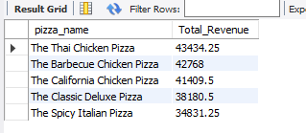

H. Bottom 5 Pizzas by Revenue

SELECT pizza_name, SUM(total_price) AS Total_Revenue

FROM pizza_sales

GROUP BY pizza_name

ORDER BY Total_Revenue ASC LIMIT 5;

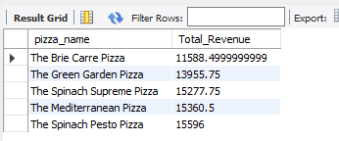

I. Top 5 Pizzas by Quantity

SELECT pizza_name, SUM(quantity) AS Total_Pizza_Sold

FROM pizza_sales

GROUP BY pizza_name

ORDER BY Total_Pizza_Sold DESC

LIMIT 5;

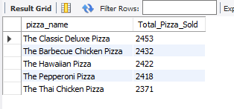

J. Bottom 5 Pizzas by Quantity

SELECT pizza_name, SUM(quantity) AS Total_Pizza_Sold

FROM pizza_sales

GROUP BY pizza_name

ORDER BY Total_Pizza_Sold ASC LIMIT 5;

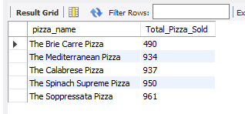

K. Top 5 Pizzas by Total Orders

SELECT pizza_name, COUNT(DISTINCT order_id) AS Total_Orders

FROM pizza_sales

GROUP BY pizza_name

ORDER BY Total_Orders DESC

LIMIT 5;

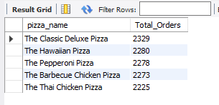

L. Bottom 5 Pizzas by Total Orders

SELECT pizza_name, COUNT(DISTINCT order_id) AS Total_Orders

FROM pizza_sales

GROUP BY pizza_name

ORDER BY Total_Orders ASC

LIMIT 5;

